Assignment #3

By: Josh Jackson

Question #1

Code:

|  |
| --- |
| #include <stdio.h>  #include <stdlib.h>  #define FALSE 1  #define TRUE 0  #define Subtract 1  #define Add 0  int main(void){  //defining variables    //time of day  int tod;  //time duration  int td;  //boolean operators for loops and switch statement  int flag, operation;  //minutes and hours separated for TOD and TD  int part1_tod, part2_tod, part1_td, part2_td;  //minutes and hours for printing end values  int minutes, hours;  //temp hours for adjusting time, carry over effect  int temphours;  //do-while to take input of Time of Day and separate into two parts  do {  printf("Enter a Time of Day based on 24 hour clock: \n");  fflush(stdout);  scanf("%d", &tod);      //operation to separate the minutes and hours of TOD  part1_tod = tod / 100;  part2_tod = tod % 100;    //Error Checking  if (part1_tod < 00 || part1_tod > 23) {  printf("Input Invalid.\n");  fflush(stdout);  flag = FALSE;  }  else if (part2_tod < 00 || part2_tod >= 60){  printf("Input Invalid. \n");  fflush(stdout);  flag = FALSE;  }  else{  flag = TRUE;  }  }while (flag == FALSE);        //do-while loop to get user input for Time Duration and separate minutes and hours  do {  printf("Enter a Time Duration to adjust 24 hour clock by: \n");  fflush(stdout);  scanf("%d", &td);    //assigning operation value for switch statement  if (td < 0) {  operation = Subtract;  }  else{  operation = Add;  }    //absolute value operation to make everything positive after assigning which method to follow (add, or sub)  td = abs(td);    //operation to separate into two parts minutes and hours  part1_td = td / 100;  part2_td = td % 100; //CHANGED THIS    //Error Checking  if (part1_td > 99) {  printf("Input Invalid. \n");  fflush(stdout);  flag = FALSE;  }  else if (part2_td < 0 || part2_td >= 60){  printf("Invalid Input. \n");  fflush(stdout);  flag = FALSE;  }  else{  flag = TRUE;  }  } while(flag == FALSE);        //switch operation to determine how to adjust time  switch(operation){    //if time duration is negative  case Subtract:  if (part2_td > part2_tod) {  part1_tod = part1_tod - 1;  part2_tod = 60 + part2_tod;  minutes = part2_tod - part2_td;  //temphours = part1_tod + 1;  hours = abs(part1_tod - part1_td);  //hours = hours + temphours;    }  else if (part2_td <= part2_tod) {  minutes = part2_tod - part2_td;  hours = part1_tod - abs(part1_td);  }    if (minutes >= 60) {  minutes = minutes - 60;  temphours = part1_tod + 1;  hours= abs(part1_tod - part1_td);  hours = hours + temphours;  }    //if minutes is less the 10 it will print with a 0 in front avoidin time such 10:1  //if hours are greater then 24 it will wrap around to 00:00  if(minutes < 10 && hours <=23){  if (hours >= 10) {  printf("The time after adjustment is %d:0%d\n", hours, minutes);  fflush(stdout);  }  else{  printf("The time after adjustment is 0%d:0%d\n", hours, minutes);  fflush(stdout);  }  break;  }  if (minutes < 10 && hours > 23){  hours = hours - (hours / 24)*24;  if (hours >= 10) {  printf("The time after adjustment is %d:0%d\n", hours, minutes);  }  else{  printf("The time after adjustment is 0%d:0%d\n", hours, minutes);  fflush(stdout);  }  break;  }  if (minutes >= 10 && hours > 23) {  hours = hours - (hours / 24)*24;  if (hours >= 10) {  printf("The time after adjustment is %d:%d\n", hours, minutes);  fflush(stdout);  }  else{  printf("The time after adjustment is 0%d:%d\n", hours, minutes);  fflush(stdout);  }  break;  }    if (minutes >= 10 && hours <= 23) {  //hours = hours - (hours / 24)*24;  if (hours >= 10) {  printf("The time after adjustment is %d:%d\n", hours, minutes);  fflush(stdout);  }  else{  printf("The time after adjustment is 0%d:%d\n", hours, minutes);  fflush(stdout);  }  break;  }  break;  //if time duration is positive  case Add:  minutes = part2_tod + part2_td;  if (minutes >= 60){  minutes = minutes - 60;  temphours = 1;  hours = part1_tod + part1_td + temphours;  }  else if (minutes <60){  minutes = part2_tod + part2_td;  hours = part1_tod + part1_td;  }    if(minutes < 10 && hours <=23){  if (hours < 10) {  printf("The time after adjustment is 0%d:0%d\n", hours, minutes);  fflush(stdout);  }  else{  printf("The time after adjustment is %d:0%d\n", hours, minutes);  fflush(stdout);  }  break;  }    if (minutes < 10 && hours > 23) {  hours = hours - (hours / 24)*24;  if (hours < 10) {  printf("The time after adjustment is 0%d:0%d\n", hours, minutes);  fflush(stdout);  }  else{  printf("The time after adjustment is %d:0%d\n", hours, minutes);  fflush(stdout);  }  break;  }    if (minutes >= 10 && hours <= 23) {  hours = hours - (hours / 24)*24;  if (hours < 10) {  printf("The time after adjustment is 0%d:%d\n", hours, minutes);  fflush(stdout);  }  else{  printf("The time after adjustment is %d:%d\n", hours, minutes);  fflush(stdout);  }  break;  }    if(minutes >= 10 && hours > 23){  hours = hours - (hours / 24)*24;  if (hours < 10) {  printf("The time after adjustment is 0%d:%d\n", hours, minutes);  fflush(stdout);  }  else{  printf("The time after adjustment is %d:%d\n", hours, minutes);  fflush(stdout);  }  break;  }  break;  }  } |

Flow Chart: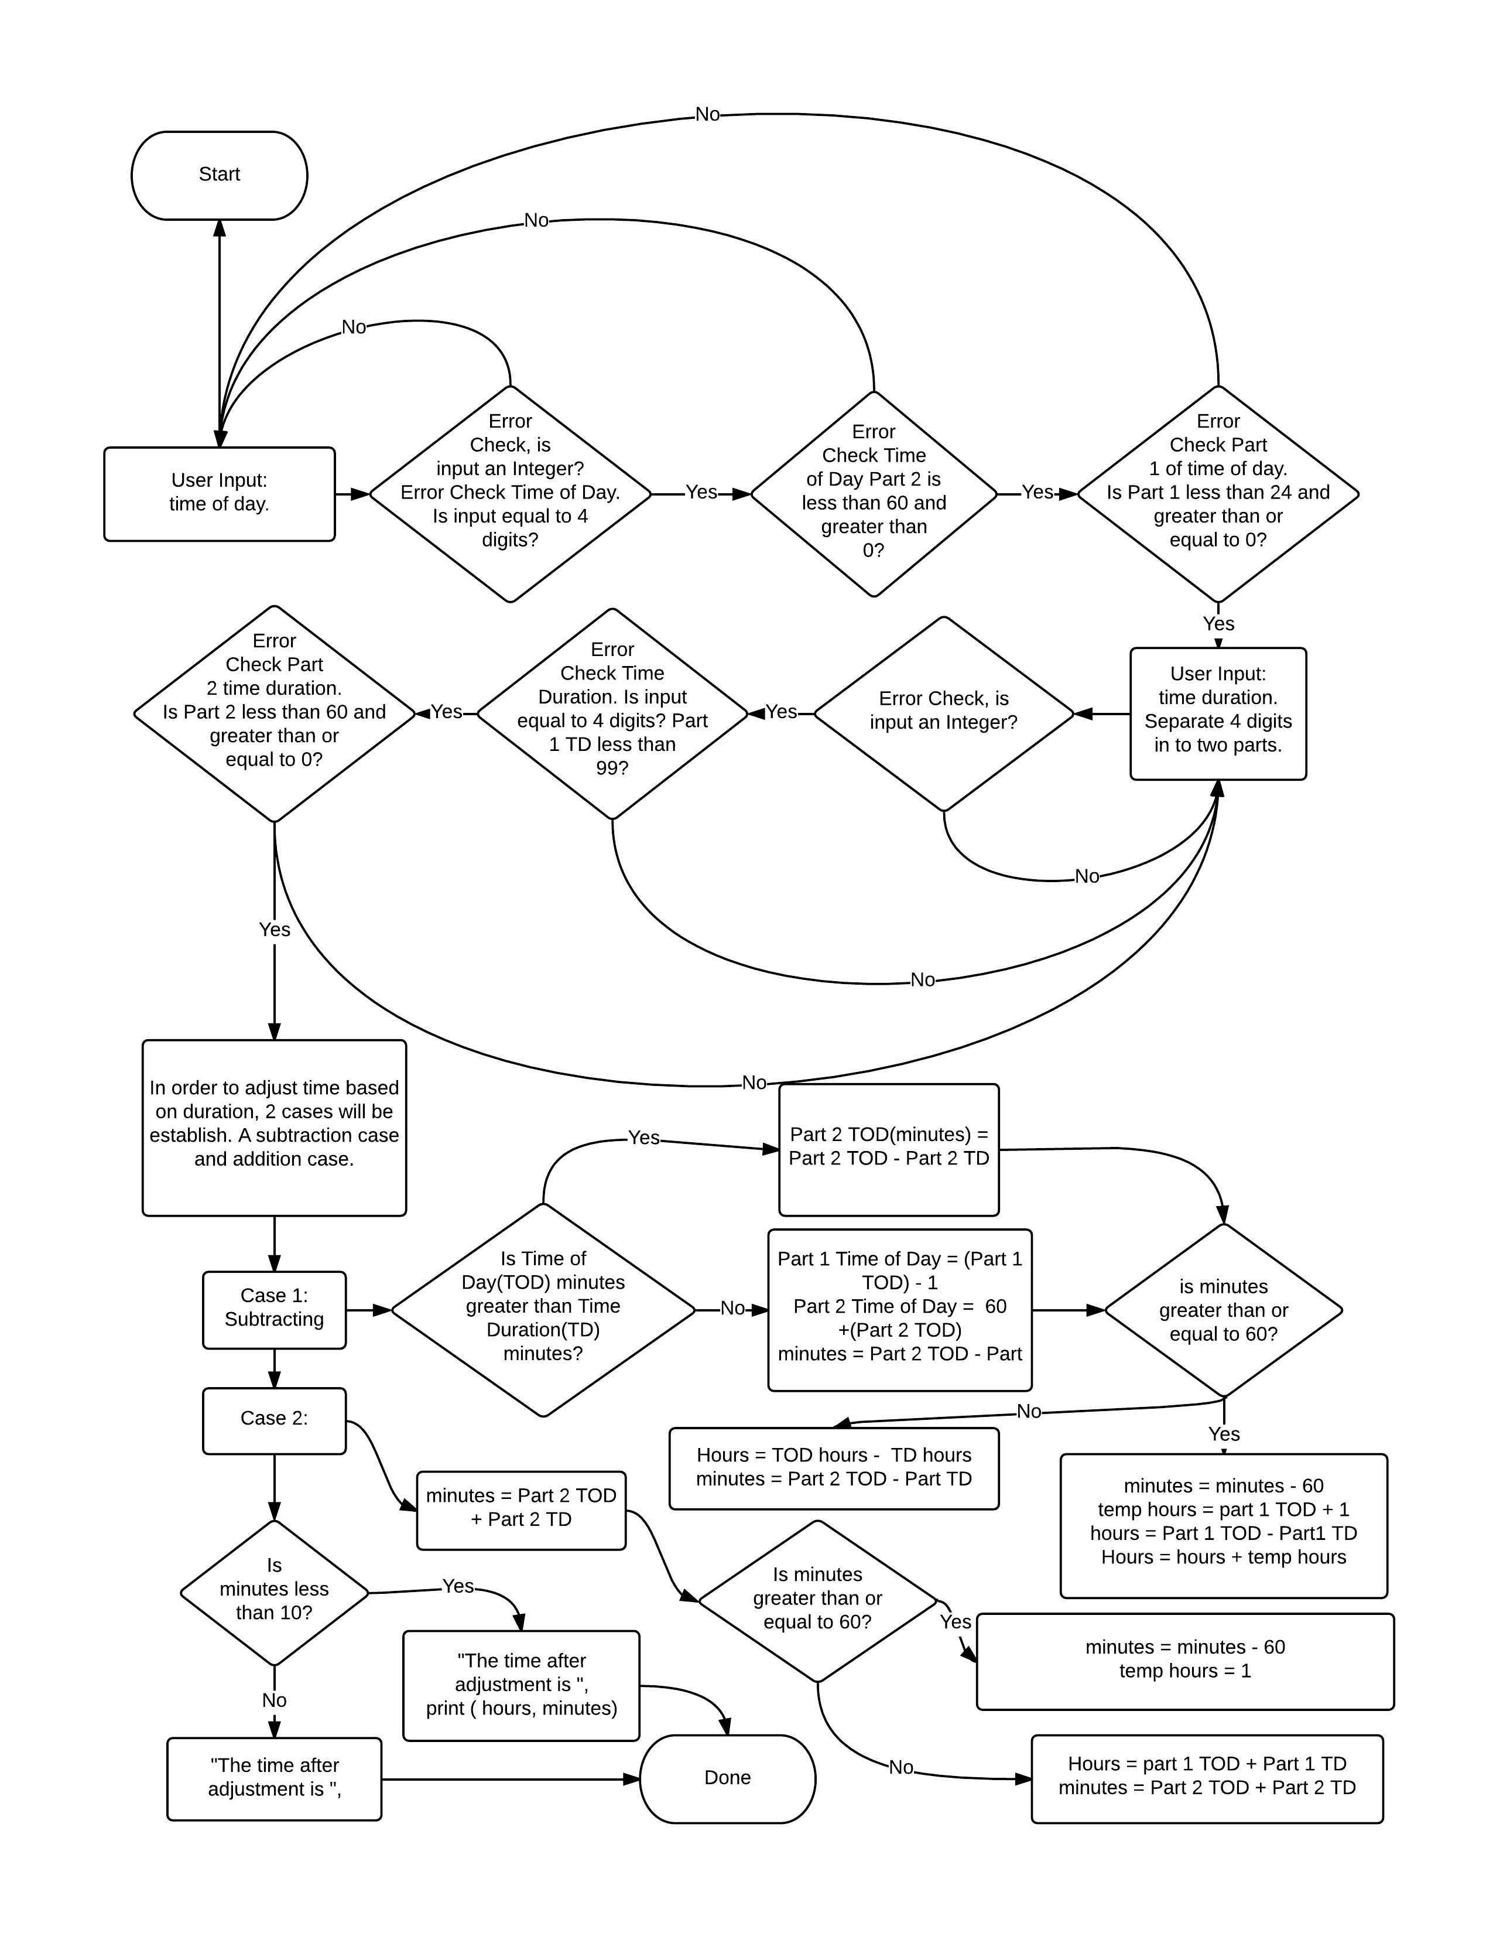

Test Cases:

|  |  |  |
| --- | --- | --- |
| Test | Input | Output |
| 1 | 6420 – 456 | **Enter a Time of Day based on 24 hour clock:**  6420  **Input Invalid.**  **Enter a Time of Day based on 24 hour clock:**  (Repeats question because TOD was invalid) |
| 2 | 2064 + 456 | **Enter a Time of Day based on 24 hour clock:**  2064  **Input Invalid.**  **Enter a Time of Day based on 24 hour clock:**  (Repeats question TOD was invalid) |
| 3 | 456 + 2064 | **Enter a Time of Day based on 24 hour clock:**  456  **Enter a Time Duration to adjust 24 hour clock by:**  2064  **Input Invalid.**  **Enter a Time Duration to adjust 24 hour clock by:**  (Repeats question as Time Duration is Invalid) |
| 4 | 456 + 500 | **Enter a Time of Day based on 24 hour clock:**  456  **Enter a Time Duration to adjust 24 hour clock by:**  500  **The time after adjustment is 9:56**  Program ended with exit code: 0 |
| 5 | 1234 + 3750 | **Enter a Time of Day based on 24 hour clock:**  **1234**  **Enter a Time Duration to adjust 24 hour clock by:**  **3750**  **The time after adjustment is 02:24**  Program ended with exit code: 0 |
| 6 | 1234 – 3750 | **Enter a Time of Day based on 24 hour clock:**  1234  **Enter a Time Duration to adjust 24 hour clock by:**  -3750  **The time after adjustment is 02:44**  Program ended with exit code: 0 |
| 7 | 1234 – 1250 | **Enter a Time of Day based on 24 hour clock:**  1234  **Enter a Time Duration to adjust 24 hour clock by:**  -1250  **The time after adjustment is 00:44**  Program ended with exit code: 0 |
| 8 | 123 + 456 | **Enter a Time of Day based on 24 hour clock:**  **123**  **Enter a Time Duration to adjust 24 hour clock by:**  **456**  **The time after adjustment is 06:19**  Program ended with exit code: 0 |
| 9 | 3 + 4 | **Enter a Time of Day based on 24 hour clock:**  **3**  **Enter a Time Duration to adjust 24 hour clock by:**  **4**  **The time after adjustment is 00:07**  Program ended with exit code: 0 |

Question 2

Code:

|  |
| --- |
| #include <stdio.h>  #include <stdlib.h>  #define TRUE 0  #define FALSE 1  int main(void){  //define variables  float loan = 0;  float interest = 0.0, monthly, n;  int flag;  char term;    //boolean value flag=true to reset when error occurs  flag = FALSE;  //error handling    /*start boolean value = false as long as it stay false it  *can continue through loop flag = true will reset loop to repeat question  */  while(flag == FALSE){  //print question if statement to check it is an integer with no spaces  printf("Amount of the Loan: \n$");  if (scanf("%f%c", &loan, &term) != 2 || term != '\n' ){  fflush(stdout);  printf("Not Valid Input\n");  flag = FALSE;  }  else{  flag = TRUE;  }  //print question if statement to check it is an integer with no spaces  printf("Yearly Interest on Loan: \n");  if (scanf("%f%c", &interest, &term) != 2 || term != '\n' ){  fflush(stdout);  printf("Not Valid Input\n");  flag = FALSE;  }  else{  flag = TRUE;  }  }  //print question if statement to check it is an integer with no spaces  printf("Amount of Monthly Payment: \n$");  if (scanf("%f%c", &monthly, &term) != 2 || term != '\n' ){  fflush(stdout);  printf("Not an Float\n");  flag = FALSE;  }  else{  flag = TRUE;  }    //print question if statement to check it is an integer with no spaces  printf("How many monthly payments: \n");  if (scanf("%f%c", &n, &term) != 2 || term != '\n' ){  fflush(stdout);  printf("Not an Float\n");  flag = FALSE;  }  else{  flag = TRUE;  }  //loop to build balance of loan amount  for (int i = 1; i <= n; i++) {  loan += (loan * ((interest/12)/100));  //if statement to stop loop and print monthly payment as remainder of balnce and set balance to 0  if (loan< monthly){  monthly=loan;  loan=0;  printf("The balance after month %d of the payment of $%.2f is $%.2lf\n", i, monthly, loan);  break;  }  loan -= monthly;  printf("The balance after month %d of the payment of $%.2f is $%.2lf\n", i, monthly, loan);  }  } |

Flow Chart:

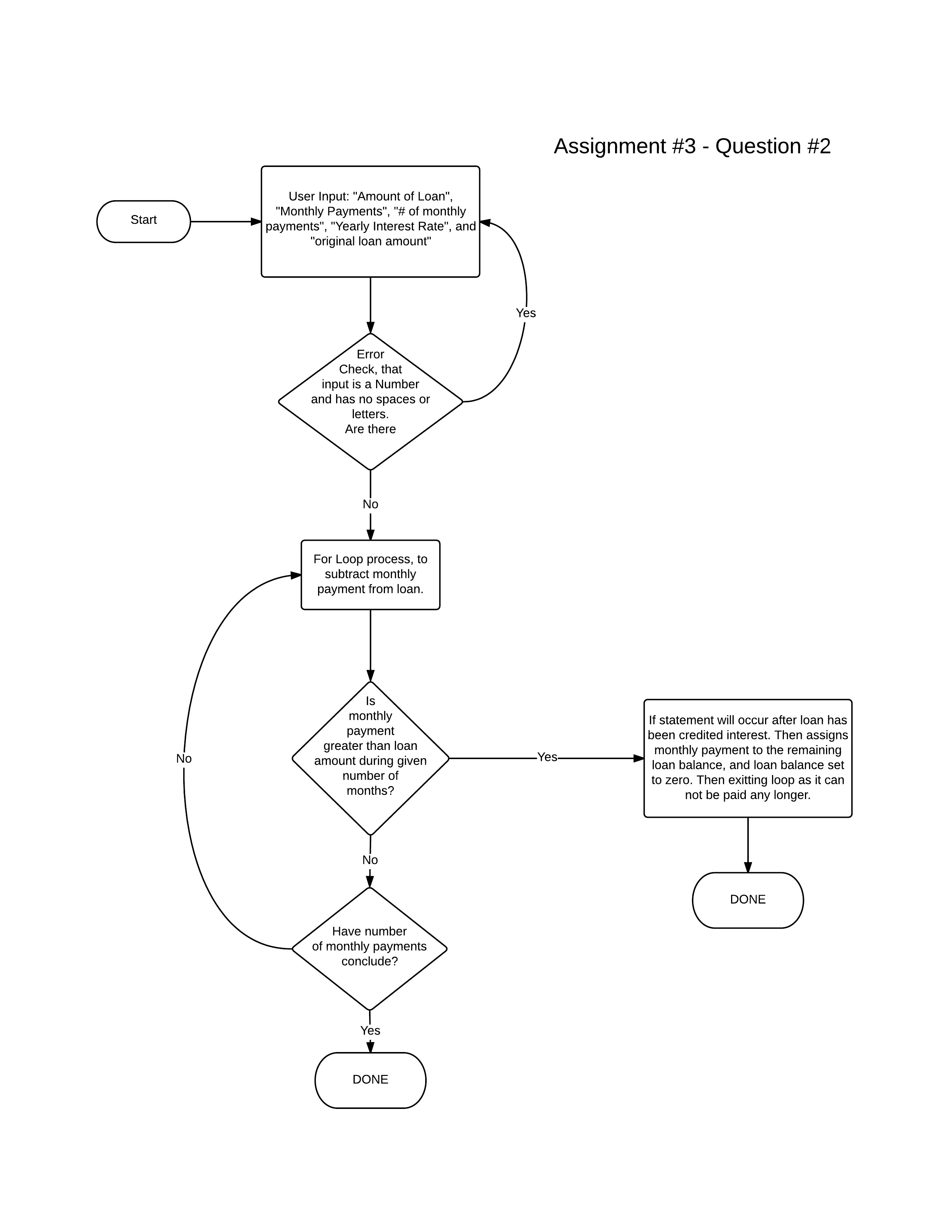

Test Cases

|  |  |  |
| --- | --- | --- |
| Test | Input | Output |
| 1 | Loan Amount: $12345  Yearly Interest: 12%  Monthly Payment: $1234  15 Payments | **Amount of the Loan:**  **$**12345  **Yearly Interest on Loan:**  12  **Amount of Monthly Payment:**  **$**1234  **How many monthly payments:**  15  **The balance after month 1 of the payment of $1234.00 is $11234.45**  **The balance after month 2 of the payment of $1234.00 is $10112.79**  **The balance after month 3 of the payment of $1234.00 is $8979.92**  **The balance after month 4 of the payment of $1234.00 is $7835.72**  **The balance after month 5 of the payment of $1234.00 is $6680.08**  **The balance after month 6 of the payment of $1234.00 is $5512.88**  **The balance after month 7 of the payment of $1234.00 is $4334.01**  **The balance after month 8 of the payment of $1234.00 is $3143.35**  **The balance after month 9 of the payment of $1234.00 is $1940.78**  **The balance after month 10 of the payment of $1234.00 is $726.19**  **The balance after month 11 of the payment of $733.45 is $0.00**  Program ended with exit code: 0 |
| 2 | Loan Amount: $12345  Yearly Interest: 12%  Monthly Payment: $543.21  15 Payments | **Amount of the Loan:**  **$**12345  **Yearly Interest on Loan:**  12  **Amount of Monthly Payment:**  **$**543.21  **How many monthly payments:**  15  **The balance after month 1 of the payment of $543.21 is $11925.24**  **The balance after month 2 of the payment of $543.21 is $11501.28**  **The balance after month 3 of the payment of $543.21 is $11073.08**  **The balance after month 4 of the payment of $543.21 is $10640.61**  **The balance after month 5 of the payment of $543.21 is $10203.80**  **The balance after month 6 of the payment of $543.21 is $9762.63**  **The balance after month 7 of the payment of $543.21 is $9317.05**  **The balance after month 8 of the payment of $543.21 is $8867.01**  **The balance after month 9 of the payment of $543.21 is $8412.47**  **The balance after month 10 of the payment of $543.21 is $7953.38**  **The balance after month 11 of the payment of $543.21 is $7489.71**  **The balance after month 12 of the payment of $543.21 is $7021.39**  **The balance after month 13 of the payment of $543.21 is $6548.40**  **The balance after month 14 of the payment of $543.21 is $6070.67**  **The balance after month 15 of the payment of $543.21 is $5588.17** |
| 3 | Loan Amount: $54321  Yearly Interest: 12%  Monthly Payment: $543.21  15 Payments | **Amount of the Loan:**  **$**54321  **Yearly Interest on Loan:**  12  **Amount of Monthly Payment:**  **$**543.21  **How many monthly payments:**  15  **The balance after month 1 of the payment of $543.21 is $54321.00**  **The balance after month 2 of the payment of $543.21 is $54321.00**  **The balance after month 3 of the payment of $543.21 is $54321.00**  **The balance after month 4 of the payment of $543.21 is $54321.00**  **The balance after month 5 of the payment of $543.21 is $54321.00**  **The balance after month 6 of the payment of $543.21 is $54321.00**  **The balance after month 7 of the payment of $543.21 is $54321.00**  **The balance after month 8 of the payment of $543.21 is $54321.00**  **The balance after month 9 of the payment of $543.21 is $54321.00**  **The balance after month 10 of the payment of $543.21 is $54321.00**  **The balance after month 11 of the payment of $543.21 is $54321.00**  **The balance after month 12 of the payment of $543.21 is $54321.00**  **The balance after month 13 of the payment of $543.21 is $54321.00**  **The balance after month 14 of the payment of $543.21 is $54321.00**  **The balance after month 15 of the payment of $543.21 is $54321.00**  Program ended with exit code: 0  (balance remains the same as monthly interest is equal to monthly payments) |
| 4 | Loan Amount: $54321  Yearly Interest: 12%  Monthly Payment: $321  15 Payments | **Amount of the Loan:**  **$**54321  **Yearly Interest on Loan:**  12  **Amount of Monthly Payment:**  **$**321  **How many monthly payments:**  15  **The balance after month 1 of the payment of $321.00 is $54543.21**  **The balance after month 2 of the payment of $321.00 is $54767.64**  **The balance after month 3 of the payment of $321.00 is $54994.32**  **The balance after month 4 of the payment of $321.00 is $55223.26**  **The balance after month 5 of the payment of $321.00 is $55454.50**  **The balance after month 6 of the payment of $321.00 is $55688.04**  **The balance after month 7 of the payment of $321.00 is $55923.92**  **The balance after month 8 of the payment of $321.00 is $56162.16**  **The balance after month 9 of the payment of $321.00 is $56402.78**  **The balance after month 10 of the payment of $321.00 is $56645.80**  **The balance after month 11 of the payment of $321.00 is $56891.26**  **The balance after month 12 of the payment of $321.00 is $57139.18**  **The balance after month 13 of the payment of $321.00 is $57389.57**  **The balance after month 14 of the payment of $321.00 is $57642.46**  **The balance after month 15 of the payment of $321.00 is $57897.89**  Program ended with exit code: 0  (monthly payments less than interest so balance increases) |

Question 3

Code:

|  |
| --- |
| #define FALSE 1  #define TRUE 0  #include <stdio.h>  int main(void){  //defining variables  double number;  double e = 1;  double temp;  int i, j;  int flag;  //char term;    flag = FALSE;  while (flag == FALSE) {  printf("Enter a floating number (anything with lots of decimal places)\n");  if(scanf("%lf", &number) != 1 || number <= 0){  printf("Input is Invalid\n");  flag = FALSE;  }  else{  flag = TRUE;  }    }    //outer loop calculating how many terms for factorial  for (i = 1; i < 20; i++) {  //defining i as temp to be used in next loop for factorial  temp = i;  //loop uses i-1 time temp to process factorial continuously  for (j = i-1; j > 0; j--){  temp = temp * j;  }  //e is equal to e + 1/factorial  e = e + (1/temp);  //if statement to end loop when factorial is less then inputted number from user  if((1/temp) < number){  printf("e is equal to %.15lf, it took %d terms to reach a number less than inputted value.\n", e, i);  break;  }  }  } |

Flow Chart:

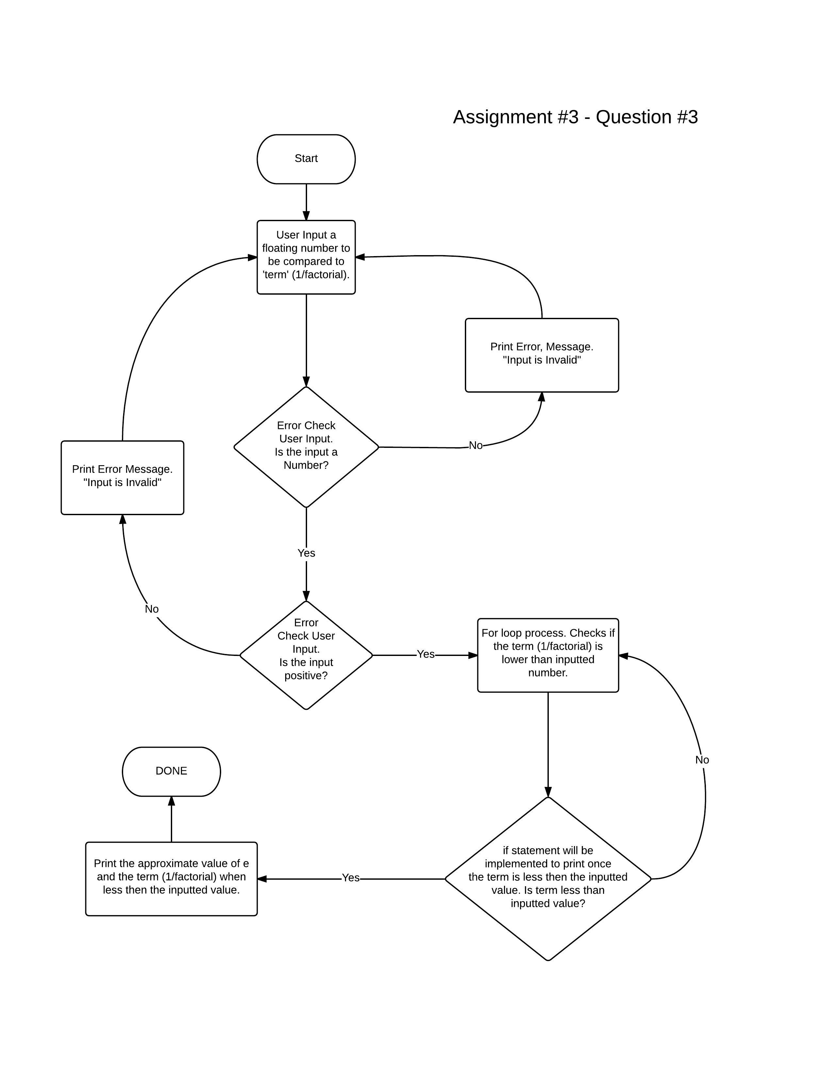

Test Cases:

|  |  |  |
| --- | --- | --- |
| Test | Input | Output |
| 1 | 0.01 | **Enter a floating number (anything with lots of decimal places)**  0.01  **e is equal to 2.716666666666666, it took 5 terms to reach a number less than inputted value.**  Program ended with exit code: 0 |
| 2 | 0.001 | **Enter a floating number (anything with lots of decimal places)**  0.001  **e is equal to 2.718253968253968, it took 7 terms to reach a number less than inputted value.**  Program ended with exit code: 0 |
| 3 | 0.0001 | **Enter a floating number (anything with lots of decimal places)**  0.0001  **e is equal to 2.718278769841270, it took 8 terms to reach a number less than inputted value.**  Program ended with exit code: 0 |
| 4 | 0.00001 | **Enter a floating number (anything with lots of decimal places)**  0.00001  **e is equal to 2.718281525573192, it took 9 terms to reach a number less than inputted value.**  Program ended with exit code: 0 |
| 5 | 0.000001 | **Enter a floating number (anything with lots of decimal places)**  0.000001  **e is equal to 2.718281801146385, it took 10 terms to reach a number less than inputted value.**  Program ended with exit code: 0 |
| 6 | 0.0000001 | **Enter a floating number (anything with lots of decimal places)**  0.0000001  **e is equal to 2.718281826198493, it took 11 terms to reach a number less than inputted value.**  Program ended with exit code: 0 |
| 7 | 0.00000001 | **Enter a floating number (anything with lots of decimal places)**  0.00000001  **e is equal to 2.718281828286169, it took 12 terms to reach a number less than inputted value.**  Program ended with exit code: 0 |
| 8 | 0.000000001 | **Enter a floating number (anything with lots of decimal places)**  **0.000000001**  **e is equal to 2.718281828446759, it took 13 terms to reach a number less than inputted value.**  **Program ended with exit code: 0** |
| 9 | 0.0000000001 | **Enter a floating number (anything with lots of decimal places)**  0.0000000001  **e is equal to 2.718281828458230, it took 14 terms to reach a number less than inputted value.**  Program ended with exit code: 0 |
| 10 | 0.00000000001 | **Enter a floating number (anything with lots of decimal places)**  0.00000000001  **e is equal to 2.718281828458995, it took 15 terms to reach a number less than inputted value.**  Program ended with exit code: 0 |